# Week 7: Introduction to Product Design - Iterative Design

|  |  |
| --- | --- |
| **Concepts** | * Continuing Bluetooth Speaker project * Using FeatureScript for screw bosses and ribs * Adding additional model detail * Version control and history * Re-ordering parametric features * Exercising top-down design |
| **Models** | * Finished Bluetooth Speaker Part Studio |
|  | |

# Bluetooth Speaker Continued

In this lesson, we will continue with designing our Bluetooth Speaker. We are going to build on our existing geometry, and use custom features like ribs and bosses, which were made using Onshape’s FeatureScript language. Finally, we are going to learn how to manage our CAD data using Onshape’s built-in History, Versioning and Branching tools. By the end of this lesson, we will have completed the Part Studio for the Bluetooth Speaker:

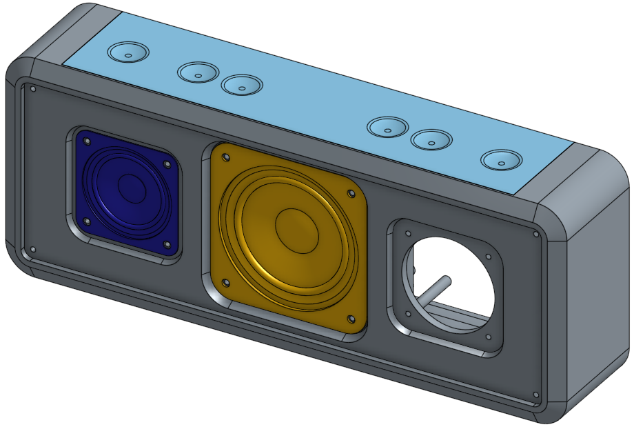

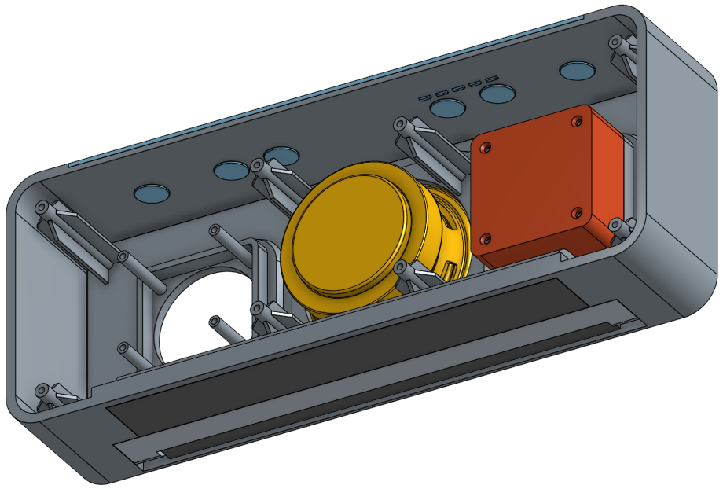

Before continuing with our model, let’s create a **Version** of it first.

1. A version is an instance of our model at a specific, and usually important, point in time that we frequently want to go back to. Since we’ve exchanged models with our partner and made changes to accommodate manufacturing restrictions, let’s capture this milestone. Click on the “Create version” button  in the top-left corner of the screen.
2. Let’s create version “Base Frame” and give it a simple description, “This version has the Bluetooth Speaker in its basic frame.” Then finish off by clicking on the “Create” button:

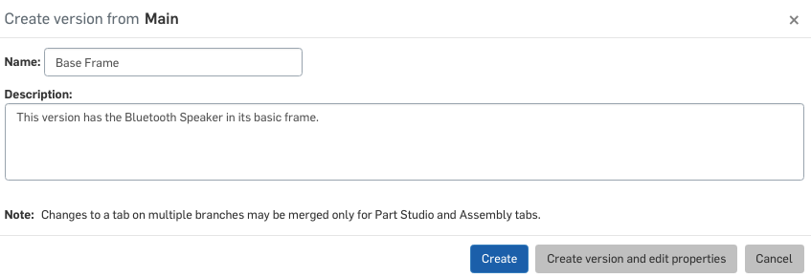

1. Now if we click on the “Manage versions and history” button  in the top-left corner of the screen, we can see the versions and history flyout. Here we can see the “Start” (where we started the model) and the “Main” (our current state), with our “Base Frame” version in between.

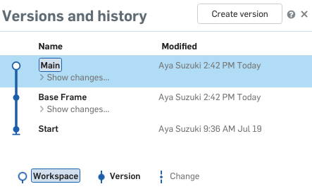

Now, let’s continue with our model! We’ll be talking more about Versions later.

1. First, let’s add a chamfer to the front corner, to make the speaker frame look a little better. Make sure to get the directions correct, the long face should be facing forward, not up. Also, let’s name this feature, “Frame Chamfer”:

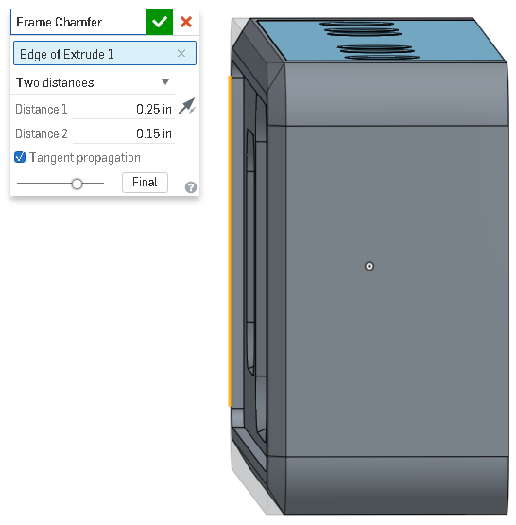

|  |
| --- |
| **Design Intent Check**: Now we’re going to be making the speaker box, highlighted in the pictures below. Notice how it sits on the Frame and how it relates to the small speaker. |

1. Next, let’s design the enclosure for the small speakers. Start by creating a sketch on the back face of the small speaker mount. Locate it by constraining it to the center of the circle in our main sketch, and make sure to fully constrain the square:

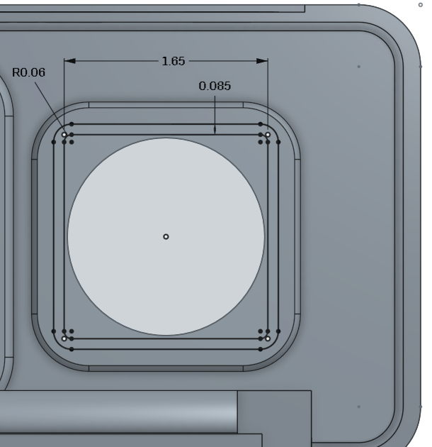

1. Extrude the sketch 0.25 in, and add it to the Frame:

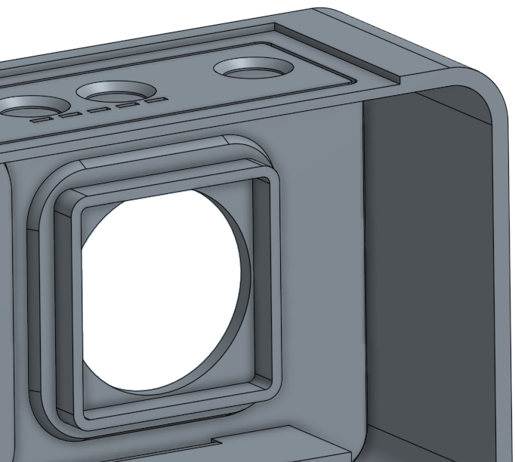

1. Next, let’s mirror this feature over to the other side (using the Right Plane):

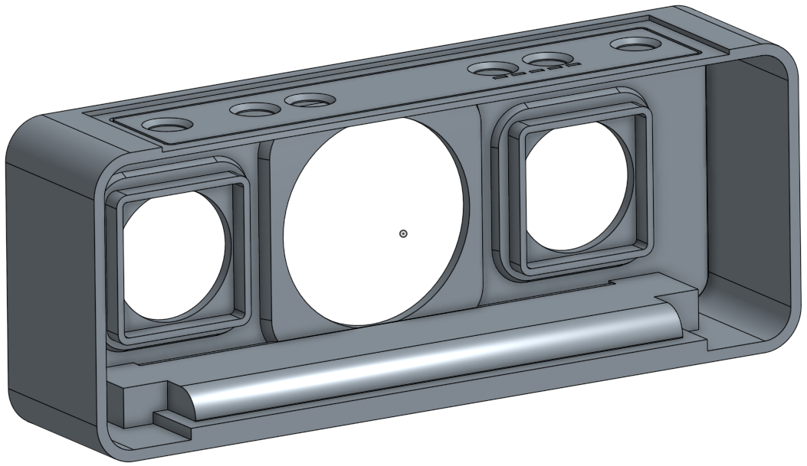

1. Next, let’s begin creating the speaker enclosure for the small speaker. To do this, select the face of the extrusion we just created, and extrude that outwards as a new part, 0.75 in. Once created, name the new part “Speaker Box”:

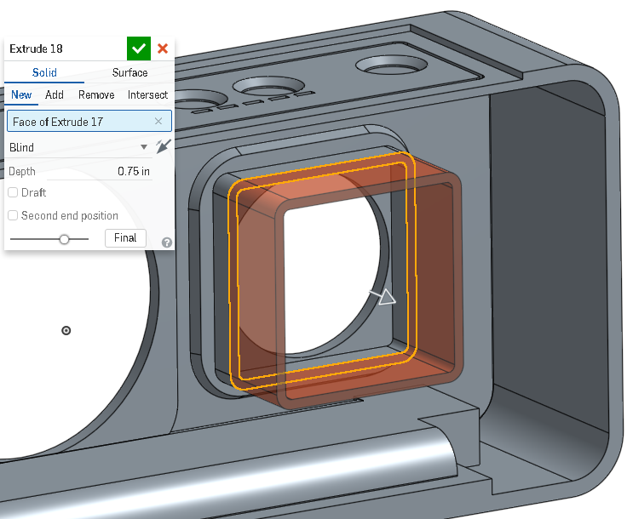

*Pro Tip: Note how we just extruded a face. We didn’t even need to create a sketch, we just selected an existing face and extruded it as a new part. This is a very convenient and powerful functionality within Onshape, and is considered to be a type of “direct modeling”. Direct Modeling is when the CAD geometry is directly manipulated, without creating any new sketches. A face can also be extruded to add or remove material from an existing part. In this case, however, if we wanted to adjust the height of the boss, we would just edit, and update, the prior feature. Sometimes, such as with imported CAD models, we don’t have any features in our Feature Tree, and Direct Modeling is very helpful.*

1. Now, we are going to cap off the small speaker enclosure. Create a new sketch on the end face of the new part we just created. Now, select all of the edges on the outside of the part. They should light up orange like this:

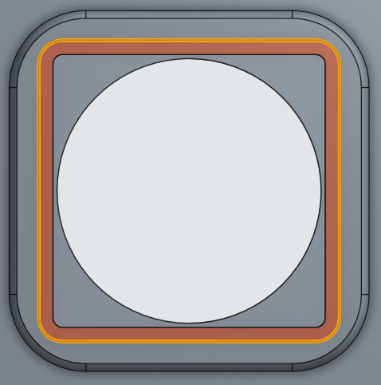

1. Now, select the “Use” icon , from the sketch toolbar. This “uses” or projects those edges onto the sketch as sketch entities (lines & arcs). They should now be black like this:

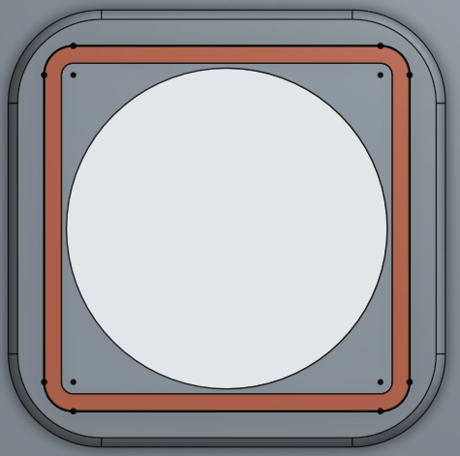

*Pro Tip: Notice how the new lines & arcs are black (meaning they are fully defined) yet they have no dimensions! By toggling the “Show Constraints” option in our sketch dialog box, we can see that Onshape has given them constraints automatically:*

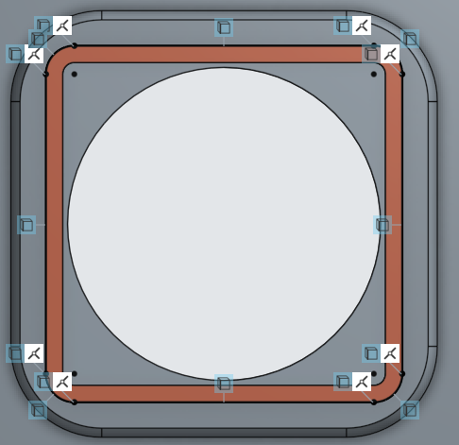

*This means that as those edges move, these lines and arcs will move as well. However, if the original geometry is manipulated too much (replaced or deleted) then the sketch will need to be rebuilt. Often, rebuilding it just takes a few seconds, as the previous sketch entities are deleted, and new ones are created again using the “use” tool.*

1. Next, extrude the sketch outwards .085 in, adding it to the new speaker enclosure part:

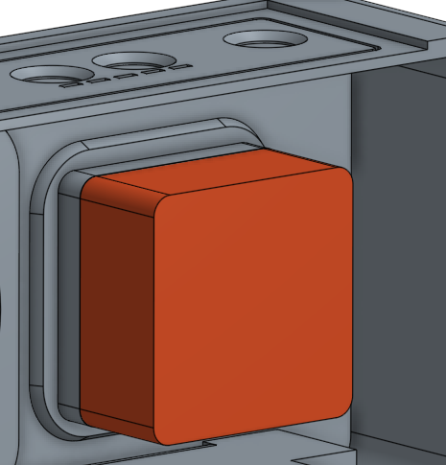

1. Next, create a plane, offset from the inside face of the speaker box .05 in, and name it “Rib Height Plane”, like this:

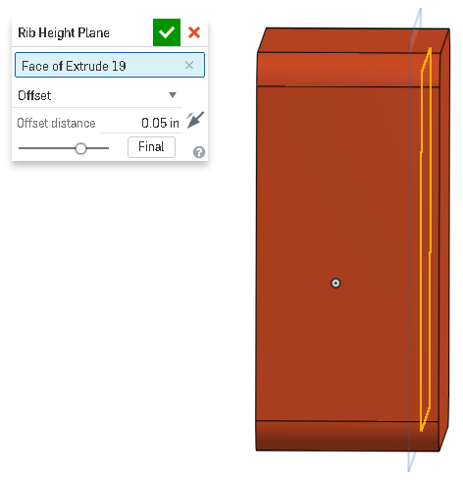

1. On this plane, create the following sketch (this is viewing the part from the “Front” orientation), and name it “Rib Sketch”:

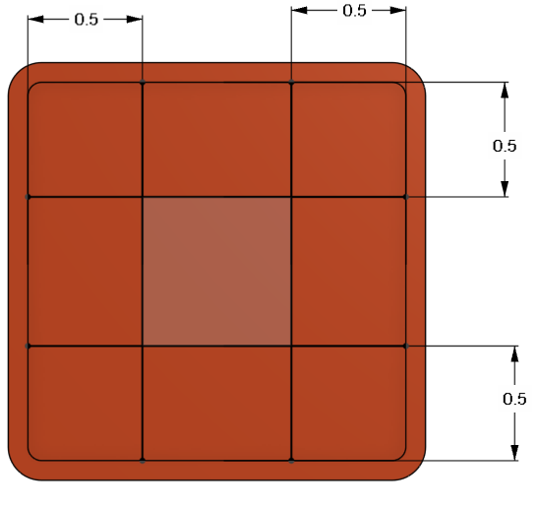

## FeatureScript

Our next feature is going to be a custom “Rib” feature that will allow us to easily create a network of ribs on this speaker enclosure which gives it strength. This feature, however, is not available in Onshape by default, instead it has been created from scratch using a scripting language invented by Onshape called FeatureScript.

FeatureScript is a programming language that is open to all Onshape users. It allows users to create any geometry possible, utilizing 3D parametric features. Existing Onshape features, such as extrude, fillet, and helix, are all written in FeatureScript by Onshape’s own developers. This means that any custom feature built in FeatureScript will work seamlessly with the existing functionality. Instead of having only a few dozen features, like traditional CAD tools, FeatureScript gives Onshape the ability to have an unlimited number of features!

This curriculum will not go into detail on the scripting language itself, but rather how to use custom features that have already been created. For more information on how to create custom features using the FeatureScript programming language, please see the separate documentation here: <https://cad.onshape.com/FsDoc/>

What is important to know, however, is that a FeatureScript feature lives in its own tab called a Feature Studio. Feature Studios are managed just like a Part Studios in Onshape, and so using an existing FeatureScript feature is much like linking to an existing Part Studio, within another document. The document which contains the Feature Studio will need to be shared with a user in order for them to use it. For this lesson, we will use two of the existing FeatureScript Samples that Onshape has already created for us.

To see all of the Featurescript Features available, go here: <https://www.onshape.com/featurescript>

1. First, select the “Add custom feature” icon  in the toolbar. The add custom features dialog box will open up, asking us to browse for a document which contains a custom feature. Select “FeatureScript samples”:

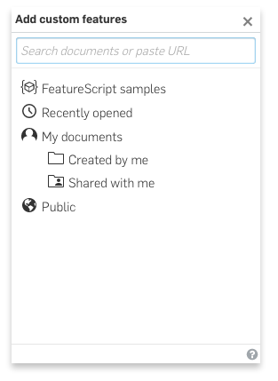

1. Scroll down and select the “FeatureScript Rib” document (a direct link to the document, including notes on how to use it can be found here: [FeatureScript Rib](https://cad.onshape.com/documents/57363e63e4b0b9290a2ccf9f/v/1f9ee286dca055776bd790a3/e/c329a190efc2812bab1232c4)):

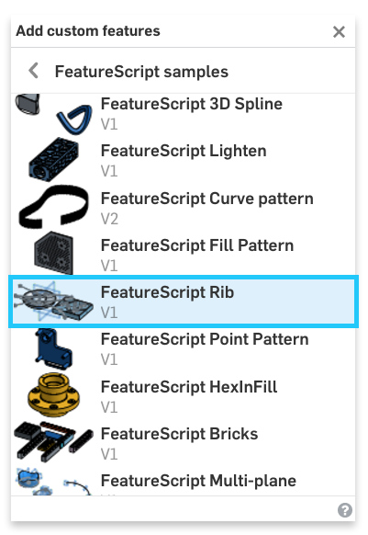

1. Now, select the “Rib” feature, and the icon will be added to the right-hand side of the toolbar:



1. Let’s use the rib command, by selecting the new  icon in the toolbar. Reference the “rib sketch” and our speaker enclosure box, and make the thickness .05 inches. Check that the rest of the options are left at default, and accept the feature:

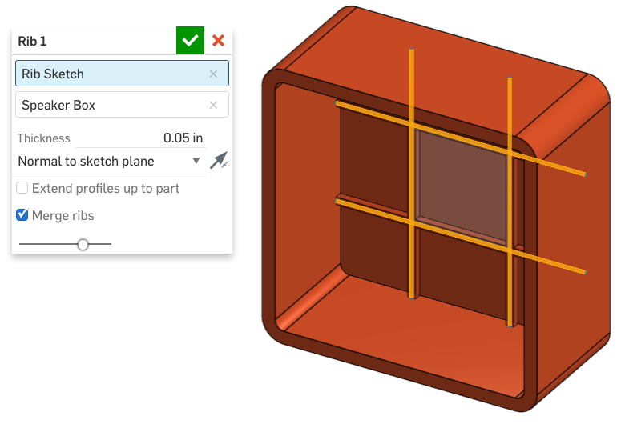

*Pro tip: In this feature, it was important to create the sketch on the new offset plane (conveniently named “Rib Height Plane” because that determined the height of our ribs. To change the height of the ribs, just edit the plane and change its offset. This works like this because we used the “Normal to sketch plane” option. In this case, where we have several items in our feature tree that were used to create new geometry, it is very helpful to give the features descriptive names. Practice makes perfect!*

|  |
| --- |
| **Design Intent Check**: Now we’re going to be adding the screw bosses to our model, highlighted below. Take a note on their heights and where they are located with respect to the speakers and Frame. |

1. Next, we are going to use another custom feature to create bosses on the inside of our Bluetooth Speaker Frame. Start by creating a new sketch on the inside of the Frame (in orange below). The sketch will only be QTY = 8 points (no lines or arcs; click on the Point Tool ), and they will be located at the centers of the corners of the Frame and at the centers of the Large Speaker holes (image below with large speaker unhidden and visibility changed to “translucent”). As shown below, the concentric constraint was used to locate the points. Name this sketch “Frame Boss Sketch”:

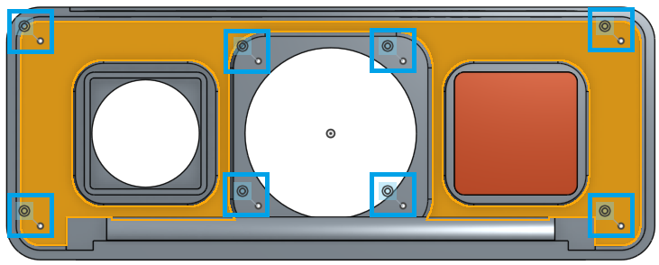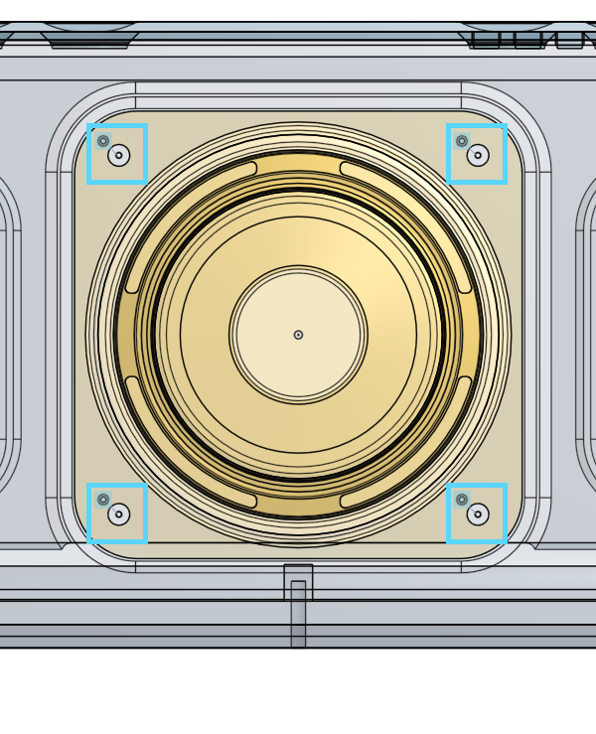

1. Next, add the custom Screw Boss Feature, from the FeatureScript Samples (a direct link to the document, including notes on how to use it can be found here: [FeatureScript Screw Boss](https://cad.onshape.com/documents/5738c86de4b06c68b35e68a5/v/b4babfe7d1d0ece235cdfe12/e/2b06e2e693176a3cc55be614)):

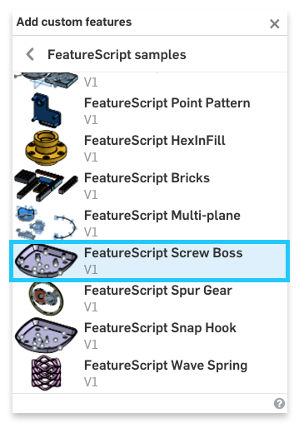

1. Select the new custom Screw Boss feature. Reference the vertices of our recently drawn sketch, and use the parameters shown below:

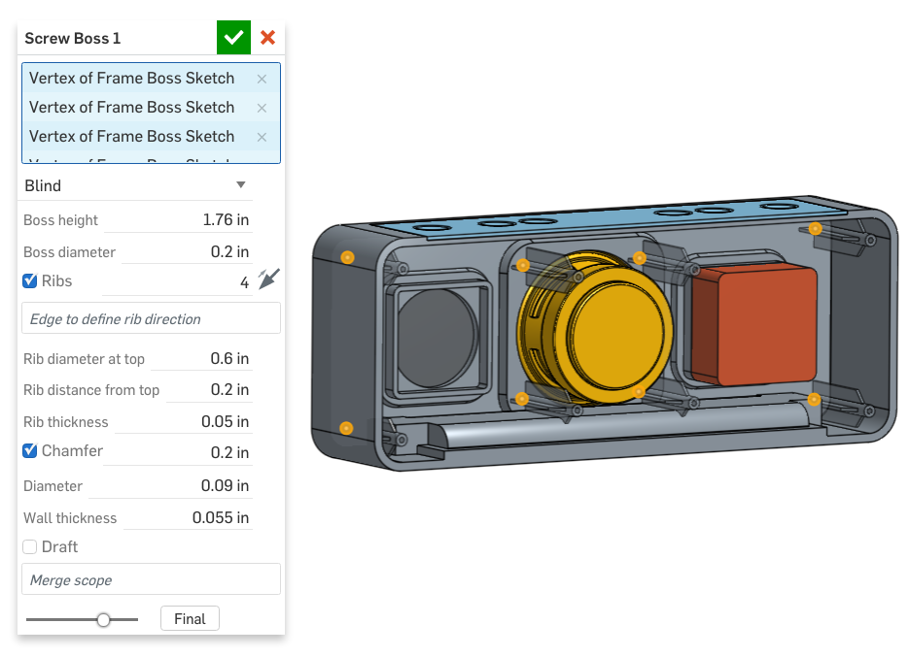

*Pro Tip: Think about how quick and easy this was. This feature automatically adds screw bosses to our geometry, no matter where they go. Also, notice how it perfectly merged the ribs with the battery compartment:*

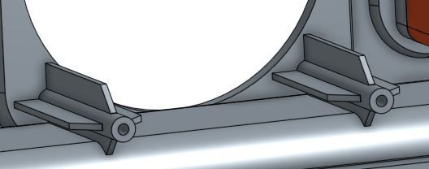

*This is a great example of just how much time you can save by creating custom features with FeatureScript. Without this feature, it would have taken at least 5 features (Extrude boss, Plane for Rib, Extrude Rib, Pattern Rib, Pattern Bosses), and to change one of the dimensions you’d have to hunt for it somewhere in the feature list. With a custom feature, it’s all in one place!*

1. Let’s add more bosses for mounting our speaker enclosure box to. Hide the Speaker box (if you haven’t already) and create a new sketch on the back face of the frame where the speaker mounts. Again, we’ll just sketch QTY = 4 points (no lines or arcs), and constrain them using the holes from the small speaker. The visibility has been changed to “translucent” for clarity:

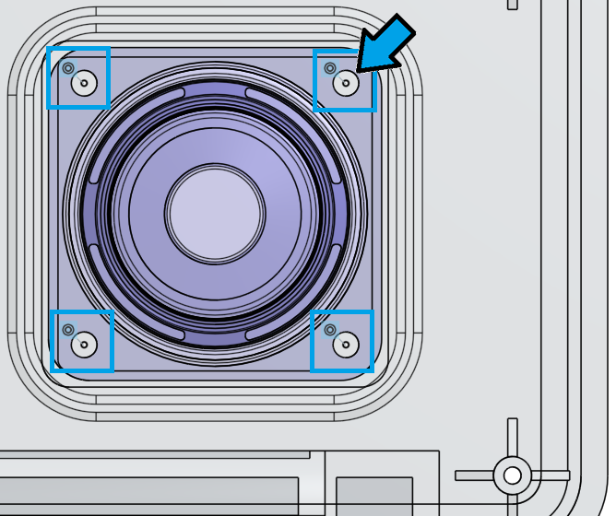

1. Again, using the custom screw boss feature, create 4 new screw bosses using the following options (no ribs):

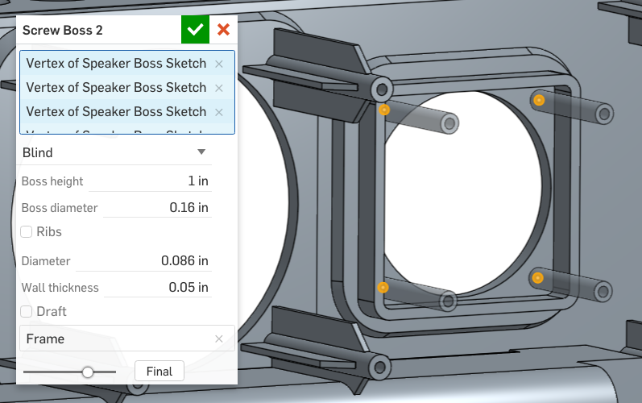

1. Next, mirror the 4 new speaker box mount bosses over to the other side using the Right Plane. Use the “Face mirror” option and for each boss, select 3 faces - outer cylinder, inner cylinder, and circular face (shown in the bottom picture):

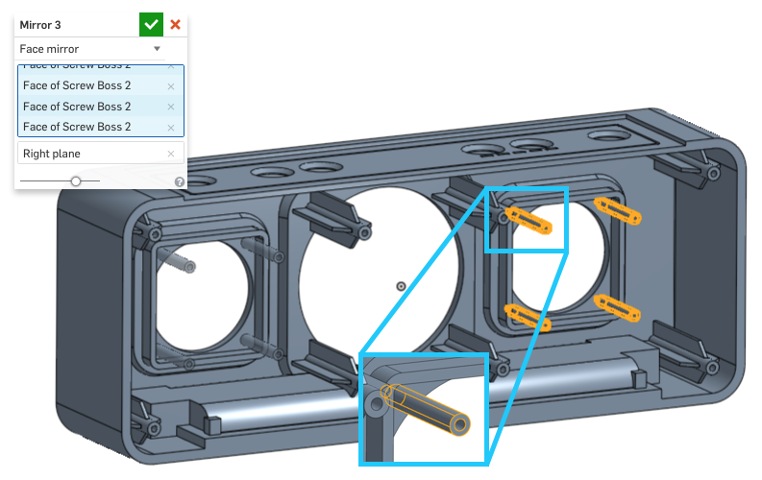

1. Next, unhide the speaker box, and create a new sketch on the back side of the speaker box. Use the “Use/Project” feature to create 4 circles that have the same diameter as the inner diameter of the box mount bosses you just made. (Note that the visibility has been changed to “Hidden edges visible” so the edges of the bosses can be selected):

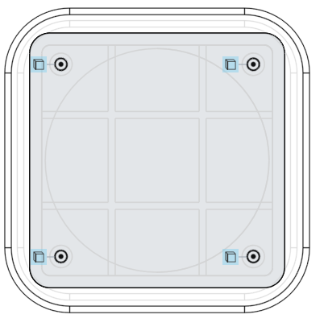

1. Use these circles to create 4 “thru holes” in the speaker box part:

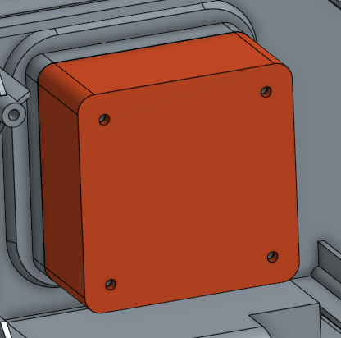

## Breather

Getting this far isn’t easy, so great job! Let’s take a second to pause and reflect before moving on.

1. We’ve utilized “Use/Project” several times to copy existing geometry (or sketch entities from another sketch) into a current sketch.
2. We’ve been periodically naming features as we see fit so that our feature list is organized, and easy to navigate.
3. We’ve been introduced to FeatureScript, which is Onshape’s programming language that gives us access to an unlimited amount of custom features. We’ve already used it to save a lot of time creating several ribs and screw bosses.

Reflecting on these advanced topics allows us to take a step back and look at our design from afar. Equally important to the details is the ability to periodically remind ourselves of the big picture. Are we making progress on our design?

## Versions and History

Let’s go back to learning more about Versions by taking a closer look at the two buttons in the top left corner of the screen  next to the Document name. These two buttons control everything that has to do with **Versions** and **History** of the Document. By using these buttons, we can look through a list of every action ever made in the document (all the way back to when the first sketch was made) and save different versions of our model for backup and collaboration purposes.

1. Click on the “Manage versions and history” button  in the top-left corner of the screen to show the versions and history flyout. To see the history, click on “Show changes” beneath the Main branch:

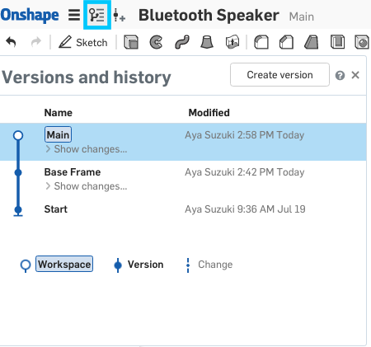

1. When you do this, you expand out every single action you made since you created the last version. It should look something like this:

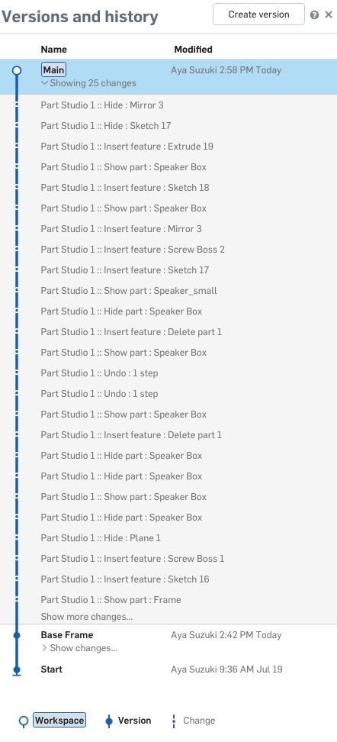

1. In addition to showing the history, you can also go back to it - both by simply viewing a previous state, or actually restoring to it. If you hover over any one of the historical actions, you get a Gear icon that can be clicked:

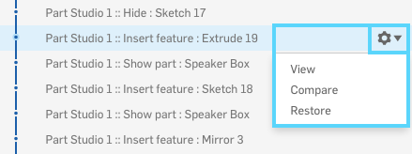

1. To go back to a past state temporarily, select “View”; to restore to it permanently, select “Restore”. (As you might imagine, Compare allows you to compare two versions, but let’s get to that functionality later on in the curriculum.) Pick any one of the points in your history, and select “View”. The part will be shown in its historical state, and you will be given a choice to either “Restore” or “Return to Main”.
2. Remember when we exchanged models with our partners last week? Try finding the action your partner took in making the change as the manufacturer. Under which version (Main or Base Frame) would the change be at? After you find it, click “Return to Main”:

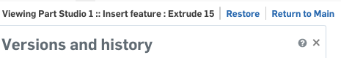

*Pro Tip: Don’t worry if you accidentally Restore a very old version, as you can always undo that as well, because Onshape always saves the history of everything! In fact, the action of restoring a previous point becomes a new point in history, and you can just restore the model again, before that!*

1. Now, let’s try going back to the “Base Frame” version we made in the beginning of the lesson. In the versions and history flyout, select “Base Frame”. Notice that versions are “view only” so you can only “Return to Main”:

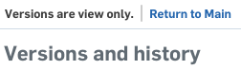

*Pro Tip: This is Onshape’s “Product Data Management” (PDM) functionality. In many engineering organizations traditional CAD programs are typically used in conjunction with an additional PDM system. PDM usually involves another layer of IT infrastructure, another layer of software on your computer, and another layer of training to go through. In addition, a designer needs to do more work (by doing things like “checking out” and “checking in” parts to work on them much like you check out books from a library). In addition, with a PDM system, multiple designers cannot work on the same part at the same time!*

*Hopefully, it is becoming apparent that, in Onshape, none of these rules or complexities exist. Simply design and collaborate. For more information on history and versions, check the video here:* [*https://cad.onshape.com/help/#version_edithistory_video.htm*](https://cad.onshape.com/help/#version_edithistory_video.htm)

|  |
| --- |
| **Design Intent Check**: We’re going to be making the battery cover next, highlighted in the pictures below. Where are the holes located? Where does it sit in the bottom of the Frame? |

1. Ok, now that the speaker frame geometry is mostly complete, we can work on the battery cover and the stand. On the left side wall of the battery cover (highlighted in orange below), create the following sketch. The left hand side is half the height of the right-hand side:

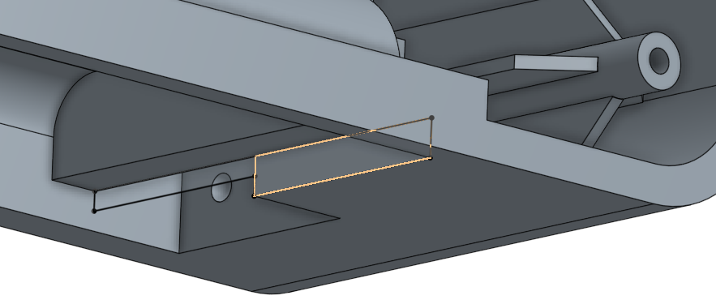

1. Extrude this sketch, as a new part, up to the opposite wall of the battery compartment. Rename this new part “Battery Cover":

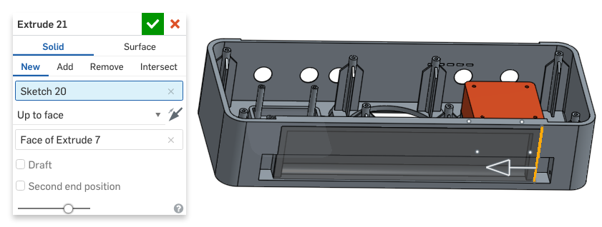

1. On the bottom-most face of the battery cover, draw the following sketch. There are 5 circles, and the bottom three circles have perfect squares centered around them. The entire pattern sits on a construction rectangle (that is not centered about the origin!):

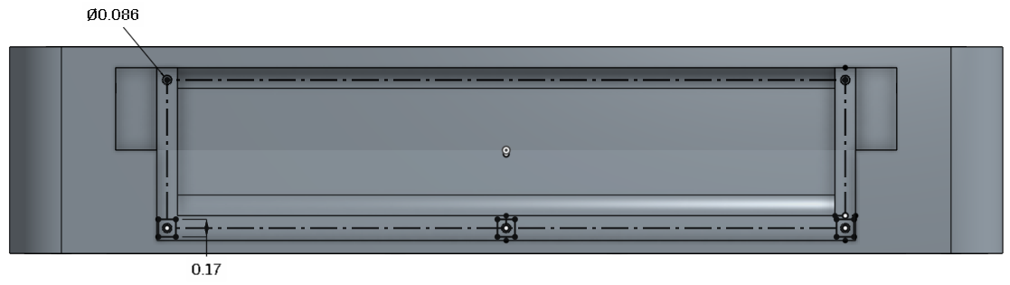

1. There are very few dimensions here yet the sketch is fully defined, because construction lines and midpoint constraints have been used. Here is a closer look at those construction lines and geometry for the bottom-middle hole (left), the bottom-right hole (center), and the top-right hole (right) below. The battery cover has been hidden for clarity:

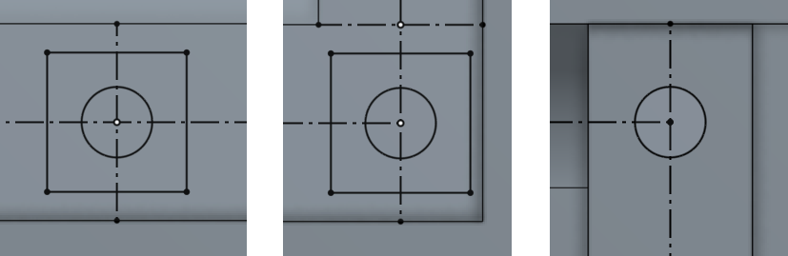

1. Next, extrude out the three 0.5” long solid squares from the previous sketch; this means you should select both the squares and the circles inside them for “Faces and sketch regions to extrude”. Use a second direction (up to face), to make sure it is flush with the inner face of the battery compartment (again the battery cover is hidden for clarity):

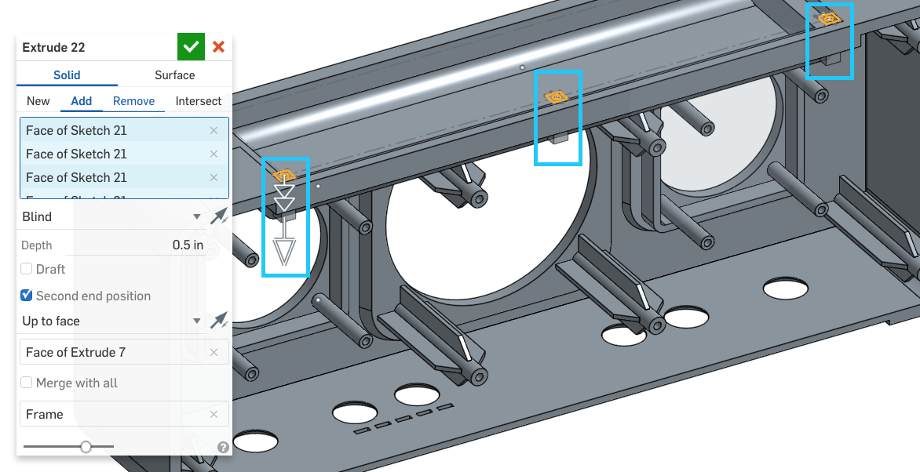

Note that the face referenced under “Second end position” is the following highlighted plane:

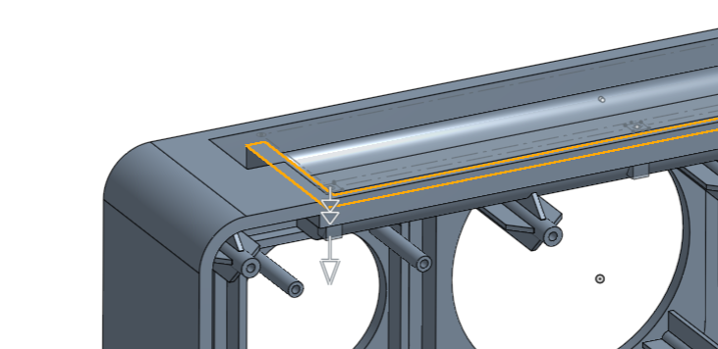

1. Next, extrude (remove) the five holes from the sketch 0.4” downwards, into the battery cover and frame:

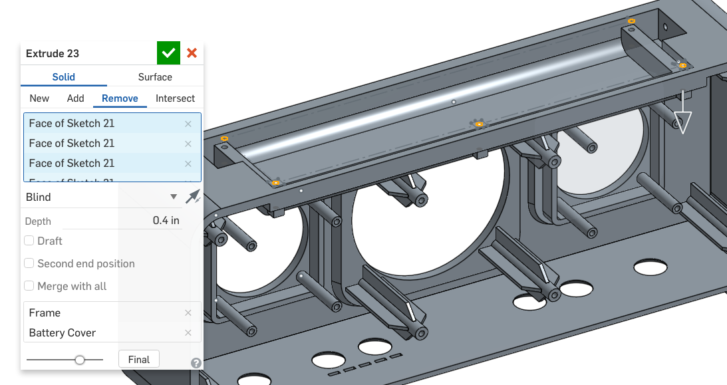

*Pro Tip: This is a perfect example of when, and how, to use a single sketch (with multiple sketch regions) to create multiple features. Here is a cross-section of the finished geometry:*

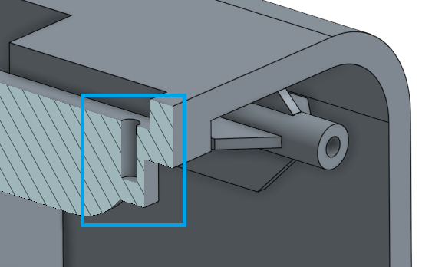

1. Next, add nine chamfers to the battery cover and the speaker box (The parts will need to be unhidden so that the hole edges may be selected):

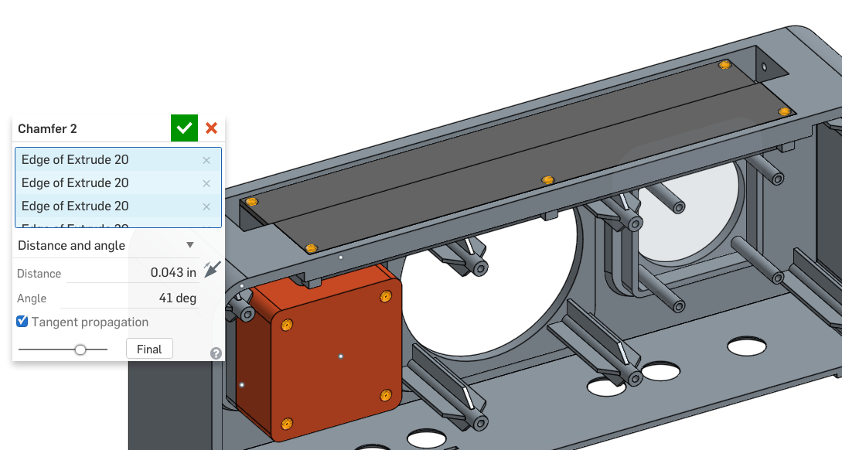

*Pro Tip: That finishes our battery cover, good job! Notice how we are able to add geometry to multiple parts at the same time (we did this with both the holes and the chamfers). Leveraging this functionality in Onshape will save a lot of time, and is smart to do when we have holes (and hardware) that is common across the entire design. Common hardware used across a design is referred to as “Design for Manufacturing” (DFM) or “Design for Assembly” (DFA) because we are taking Manufacturing and Assembly constraints into our CAD design. With multi-part Part Studios, Onshape makes it very easy!*

|  |
| --- |
| **Design Intent Check**: Now let’s make the rotating stand. Where does it fit in relation to the battery cover we just made? |

1. Next, let’s create the rotating stand. First hide the battery cover. Start by drawing the following sketch on the left side of the battery compartment wall. The constraints are shown as quite a few have been used to allow us to only need one dimension. The hole for the stand’s pin has been reused with the “Use/Project” tool, and there are no constructions lines:

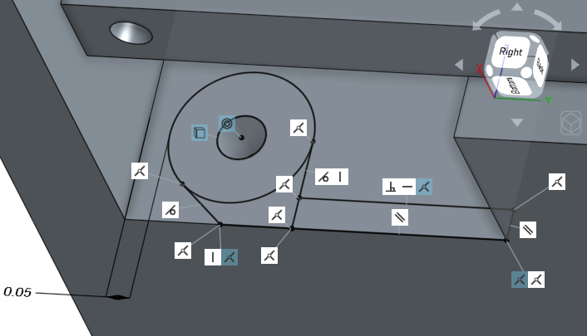

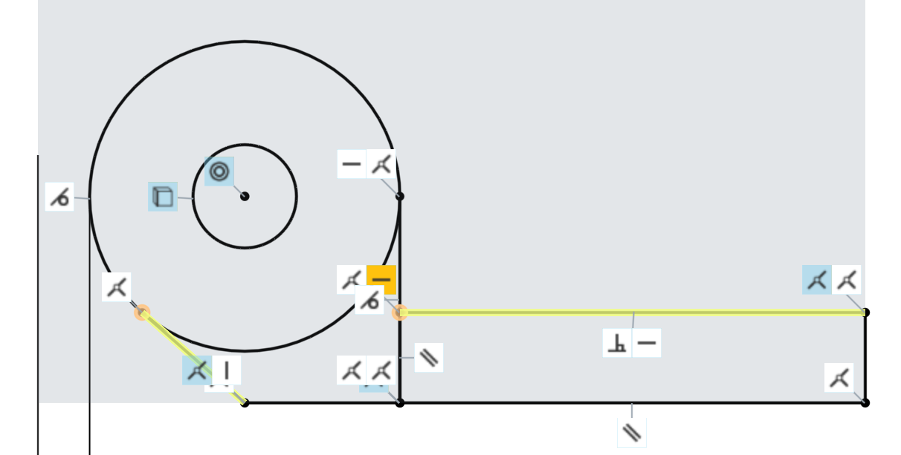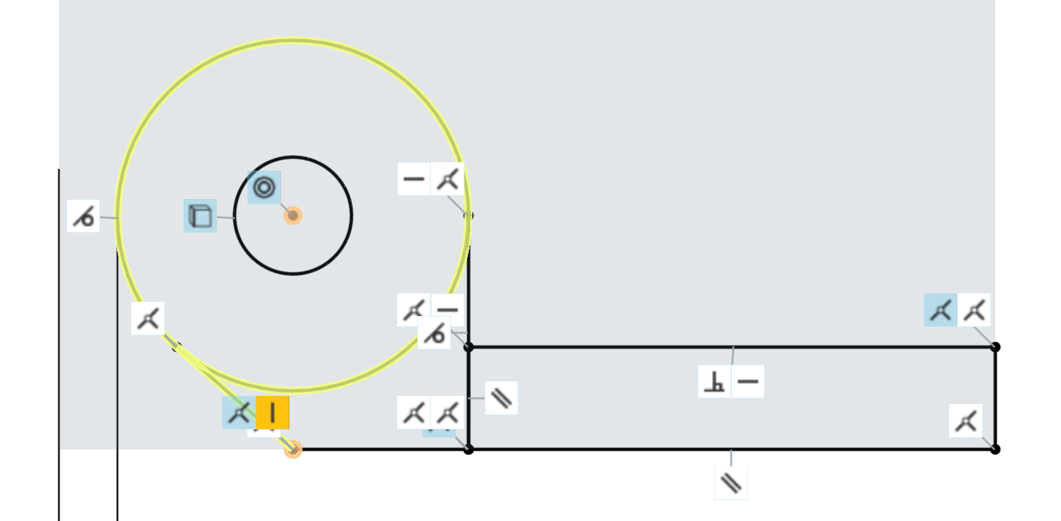

*Pro Tip: Notice how in the above picture, there are constraints colored white, and constraints colored blue. The white constraints reference sketch entities in the current sketch, and the blue constraints reference geometry outside of the sketch (such as other sketches or previously created geometry). Visual cues like this not only provide useful information, but also make troubleshooting easier, should the need arise.*

1. Next, extrude out just the rectangle portion of the sketch, up to the opposite side of the battery compartment:

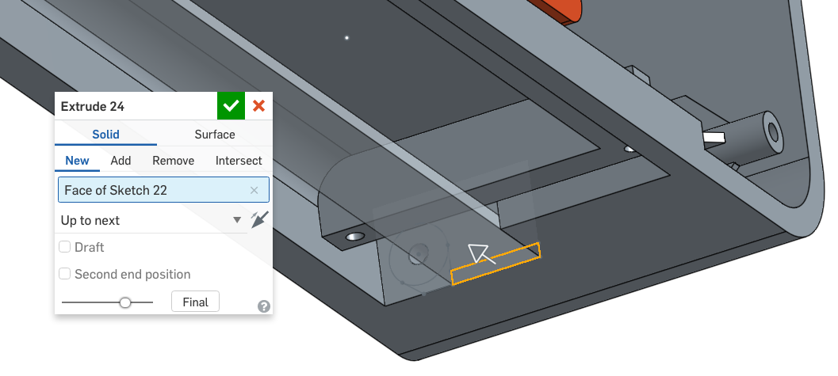

1. Next, extrude the other two sketch profiles up to the next wall (the model has been flipped around for clarity):

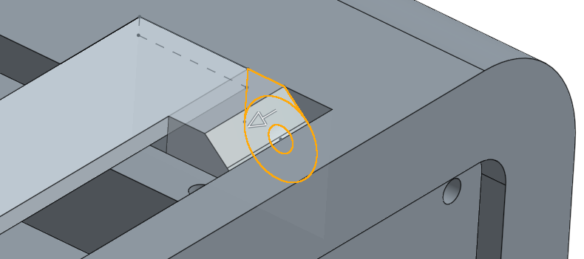

1. Now, we’ll create the other side. Start by creating a new sketch, and using the “Use/Project” tool to copy entities from the previous geometry:

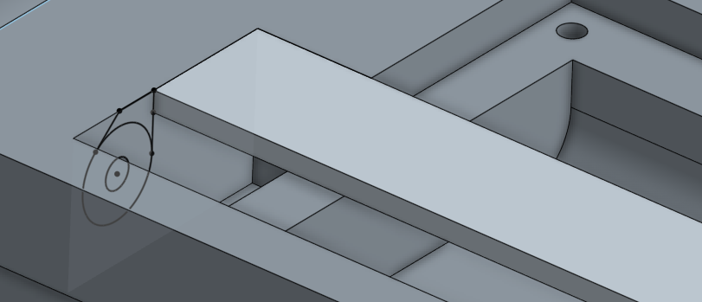

1. And protrude it the same way as before:

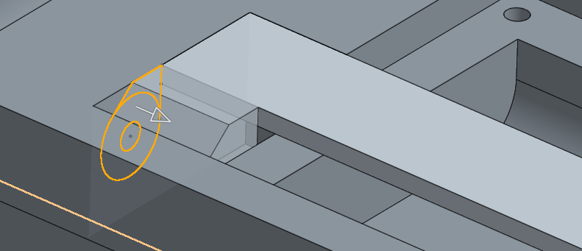

*Pro Tip: You may be wondering why we did not choose to use the “mirror feature” here. The reason being, is that this geometry uses the “up to face” depth option. The mirror feature does not always work reliably (or at all) when using mirror and “up to face”, because there is no face in the second direction. This is a typical limitation of all CAD tools.*

1. Rename the new part “Stand”. Next, let’s finish the stand by adding 4 fillets with radii of 0.125” to the sharp corners (the frame has been hidden for clarity):

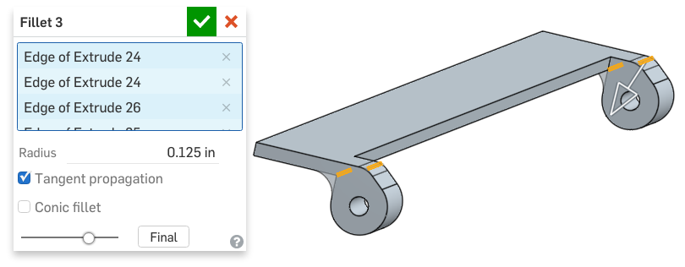

|  |
| --- |
| **Design Intent Check**: We’re going to finish off with the back cover. How does it relate to the screw bosses we made earlier? |

1. Finally, let’s finish this design by putting a cover on the back of the speaker frame. Start by creating a new sketch on the back face of the frame. Once again, using the “Use/project” tool, copy the outer profile of the frame using the existing geometry:

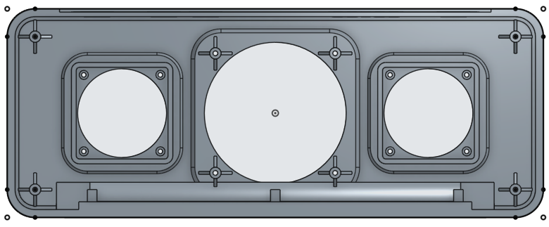

1. Extrude out the sketch 0.25 inches, and create a new part, called “Cover”:

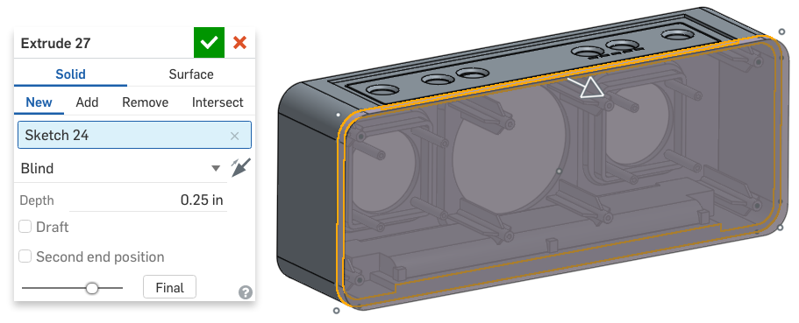

1. Create a new sketch on the back face of the cover and, once again use the “Use/Project” tool, copy the profile of the step in the front of the frame (from sketch two; shown in grey below) onto the back cover:

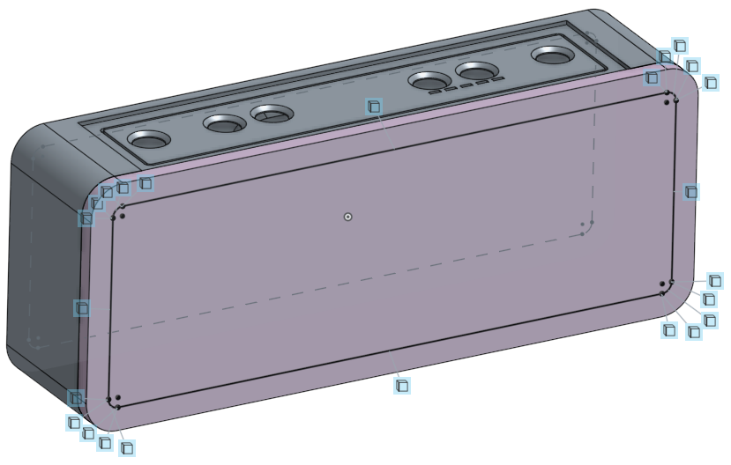

1. Next, create the step in the back cover, by removing 0.1” of material:

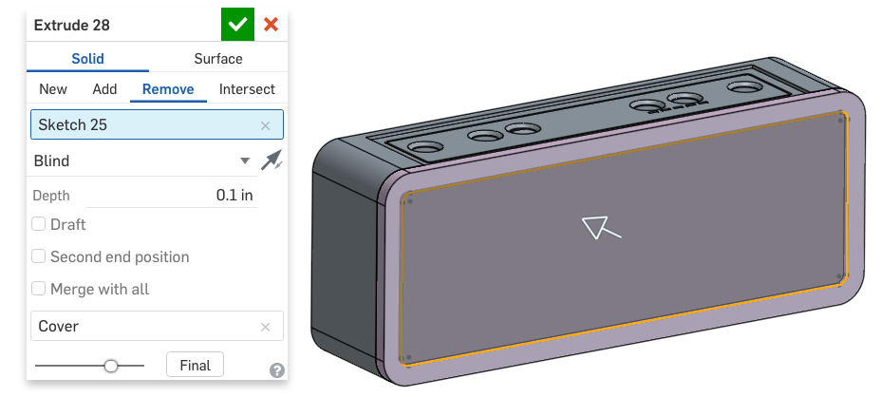

1. Next, let’s create a new sketch on the face of the cover, and use the “Use/Project” tool to copy the holes from the screw bosses onto the sketch as circles:

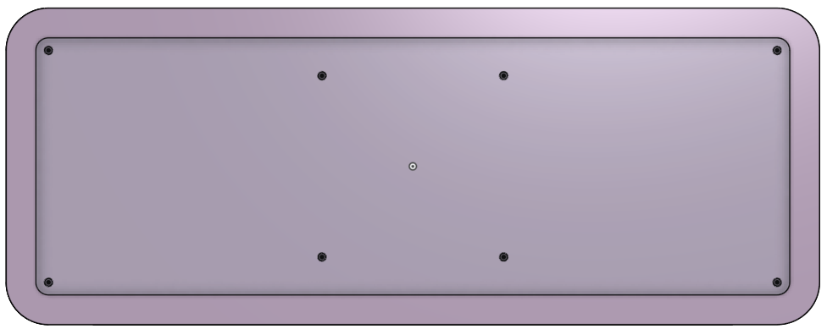

1. Now extrude the circles through the entire cover part (remember your merge scope!):

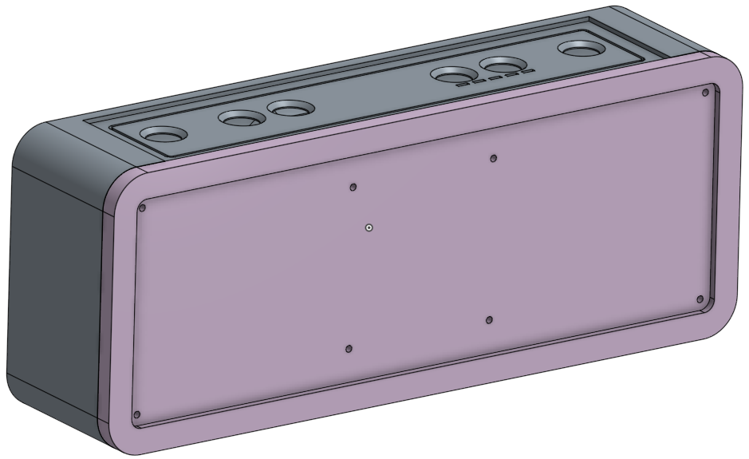

## Re-ordering Parametric Features

*Pro Tip: Next, we are going to add a chamfer to the cover that exactly matches the chamfer that is on the front of the frame. However, since it is not a sketch, we cannot just copy it using the “Use/Project” tool. In addition, due to the way we have modeled things, we cannot mirror it either. So what do we do?*

*Well, why not just use the same feature to create both chamfers? In Onshape, the order of the features in the feature list matters - sketches have to come before 3D features, and you can only reference entities in features that have already been made. The only problem is that we have created things a little out of order. The Frame Chamfer was created before we created the cover. In this case, we can easily justy reorder the features, by dragging the Frame Chamfer down, and putting it after the cover features. The feature tree below on the left shows the Frame Chamfer in its original position. As you click and drag it down, it will temporarily highlight with a blue dotted line (shown below, in the middle), and when you let go, it will look like the feature list on the right.*

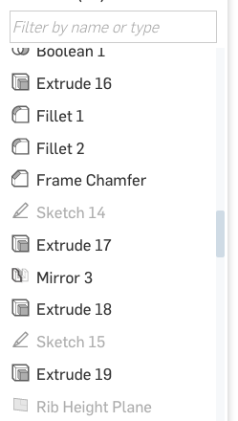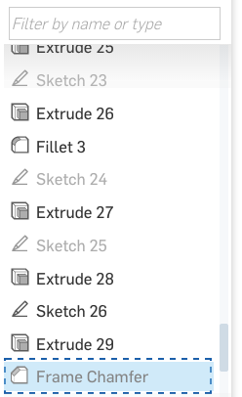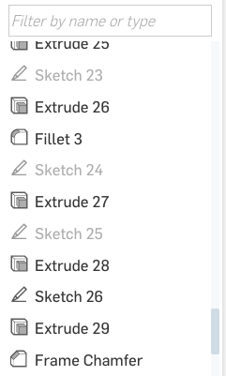

*Onshape will take a moment to recalculate the model, but the final geometry will look identical:*

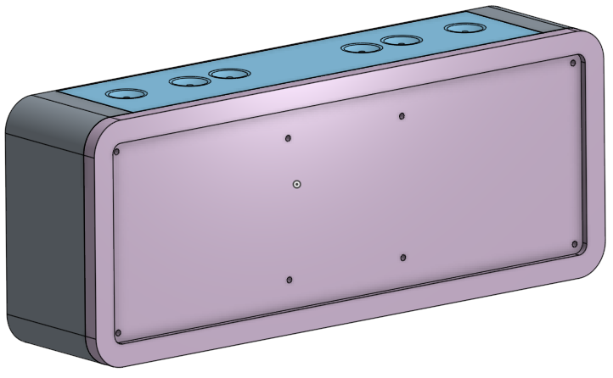

*Now, we just double-click the chamfer, and add the outside edge on the cover:*

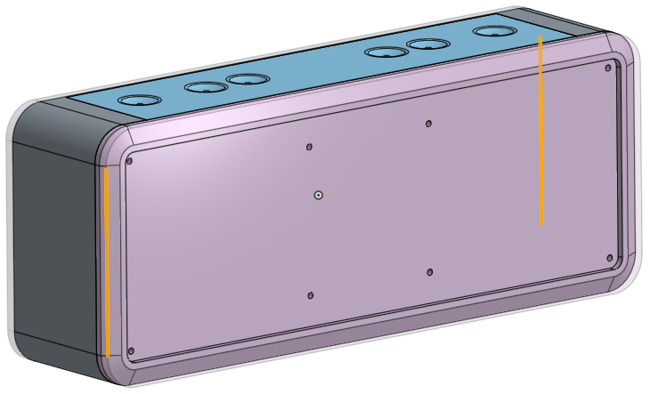

1. Let’s finish up the speaker Face part. Using the shell feature, hollow out the back of the “Face” part (facing the frame), leaving a .02” thickness. All other parts have been hidden for clarity:

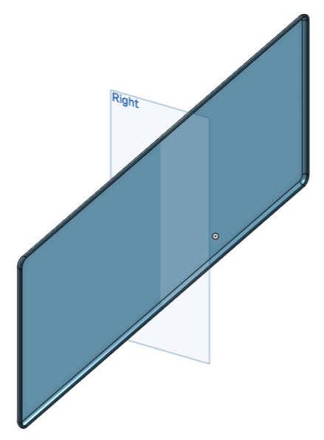

1. Next, on the front outside corner, add a .04” fillet (a cross-section of the Face using the Right Plane is on the right for clarity):

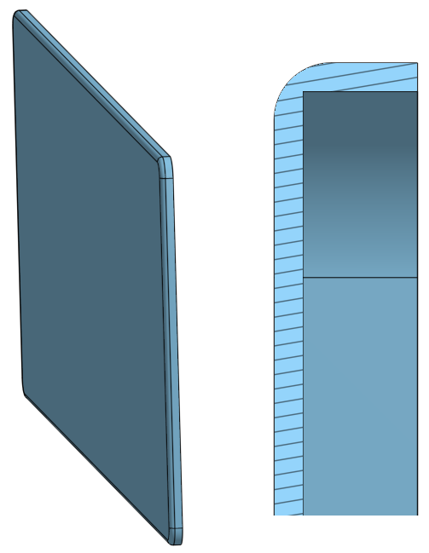

1. Now, let’s say the radius is just too small, so let’s update the radius to make it larger. Double-click on the fillet in the feature tree, enter .075” and accept. Notice that there the fillet feature is red in the feature list, and there is no fillet on the model:

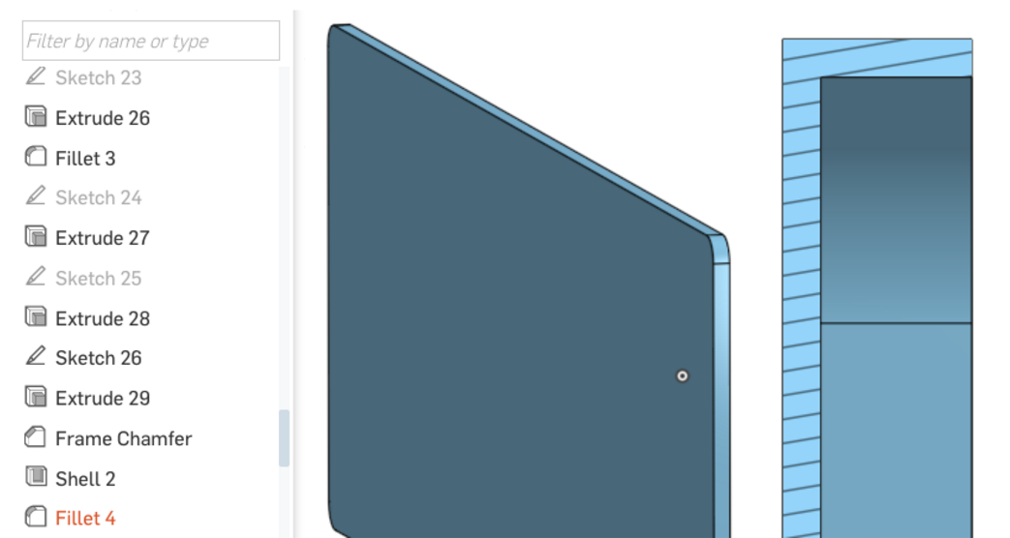

1. Now, slide the fillet up the tree, just above the Shell 2 Feature:

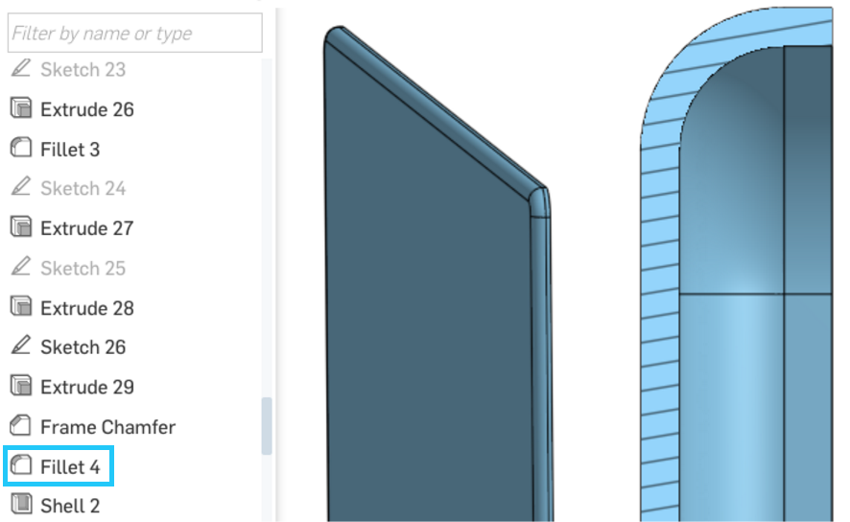

1. The larger fillet failed because it was so large, that it was cutting right through the corner of the part and into the hollow shell. By re-ordering it, not only did we solve the issue, but we also took advantage of the shell features ability to automatically create the inner radius as well. Good job! The Bluetooth Speaker design is finally complete! Let’s save a version, called V3. It should now look like this (with the face/cover temporarily hidden for clarity):

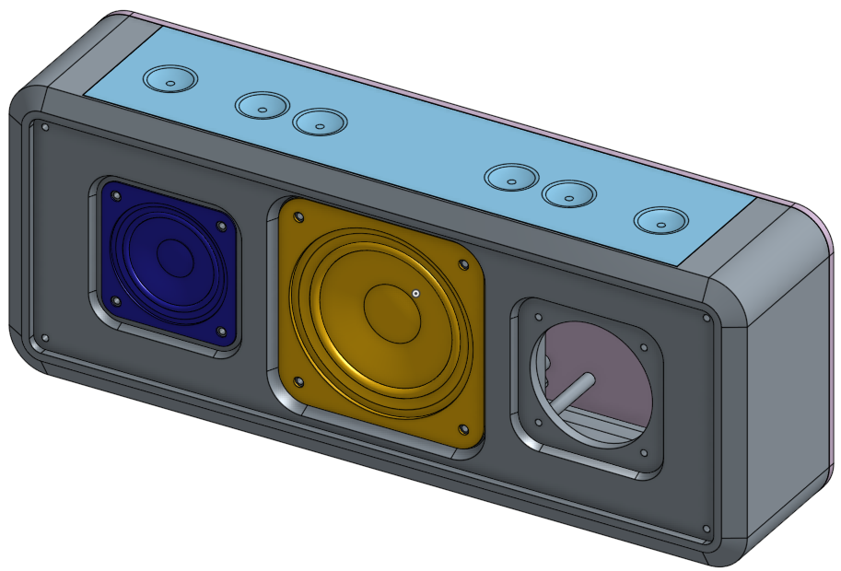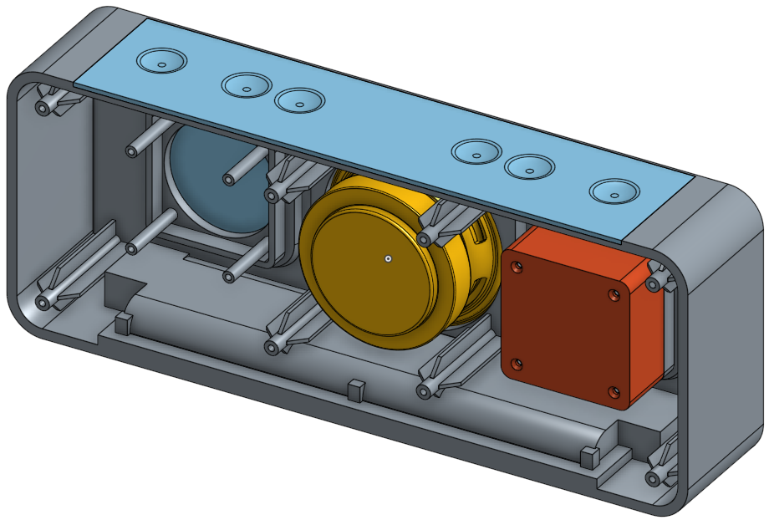

## Exercising Top-Down Design

If you recall, at the beginning of [Week 6](https://docs.google.com/document/d/1QOGTUYSh6Mdn7Bpy-AkBRmVrNxr9dljDAFoIg4phGQQ/edit#bookmark=id.qau81dqdgfir), we created our original sketch in a way that referenced the location of the “derived part” speakers. We did this so if we wanted to move the speakers around, the design of the Frame would update. This approach is an example of “Top-Down” design. Let’s exercise this by changing the width of our Bluetooth Speaker:

## 

1. Start by navigating to the part studio. Edit the “Derived 2” feature by double-clicking it, and move the small speaker over by 1 inch (X translation should go from -3.5827 to -4.5827) and select the green checkmark:

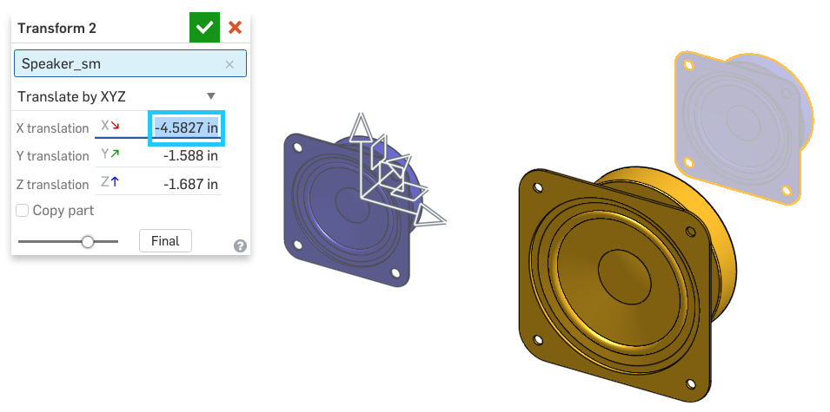

1. Our Bluetooth Speaker design should now look like this. Notice how the frame is wider, and all of our features have moved as well:

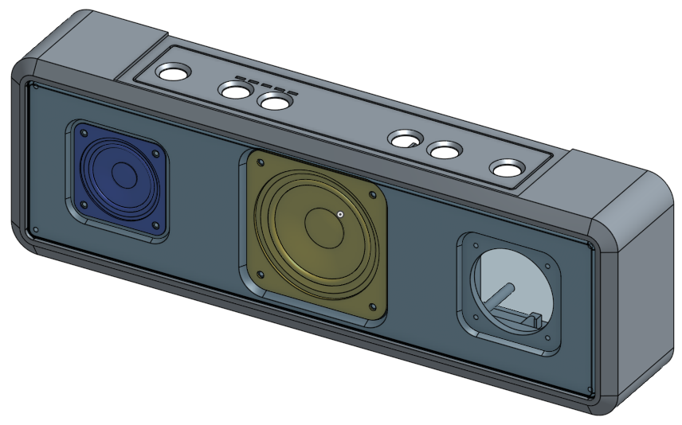

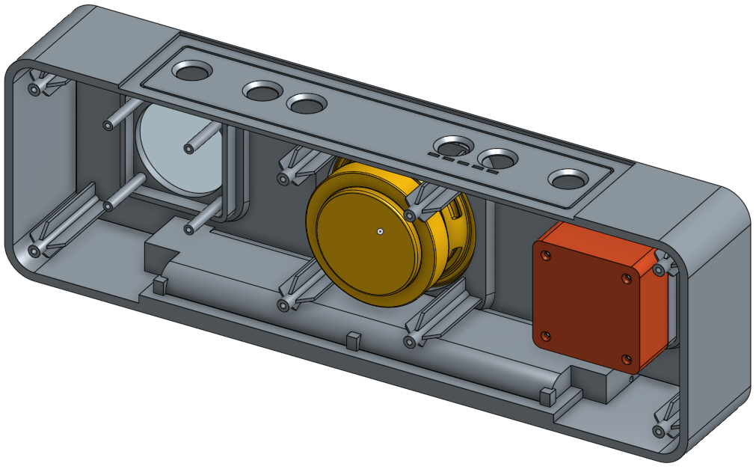

Notice that everything in the model updates - the speaker holes, speaker box, and screw bosses all move symmetrically outward to accommodate the different speaker position. Congratulations! We have successfully exercised good top-down design and applied good design intent to our model. We’ll be practicing more of this in the homework.

# Summary

Let’s take a second to reflect what we learned in this lesson.

1. We created Versions of our model.
2. We used FeatureScript to create ribs on our Speaker Box and screw bosses on our Frame.
3. We re-ordered parametric features in the Feature Tree.
4. We updated our model with different speaker positions and saw what it meant to have good top-down design.

Next week, we will make an Assembly of the Bluetooth Speaker and import important documentation to our Onshape document!